21 October 2016

How to create a project in SoapUI from exported XML project file and run it

1. Start SoapUI
2. File -> Import Project
3. Find XML project file , open
4. Double click at test case PostPutCancel1 and run it

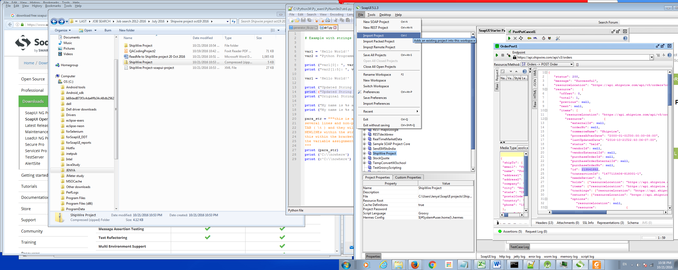

Point out the path :

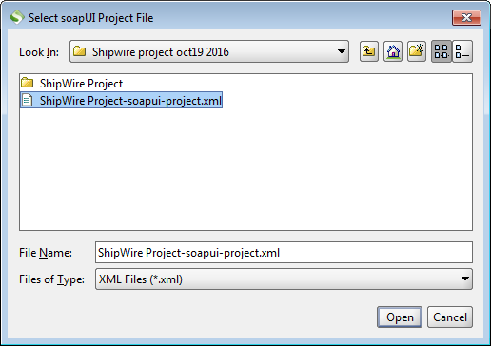

In my case I just got a clone- Project :

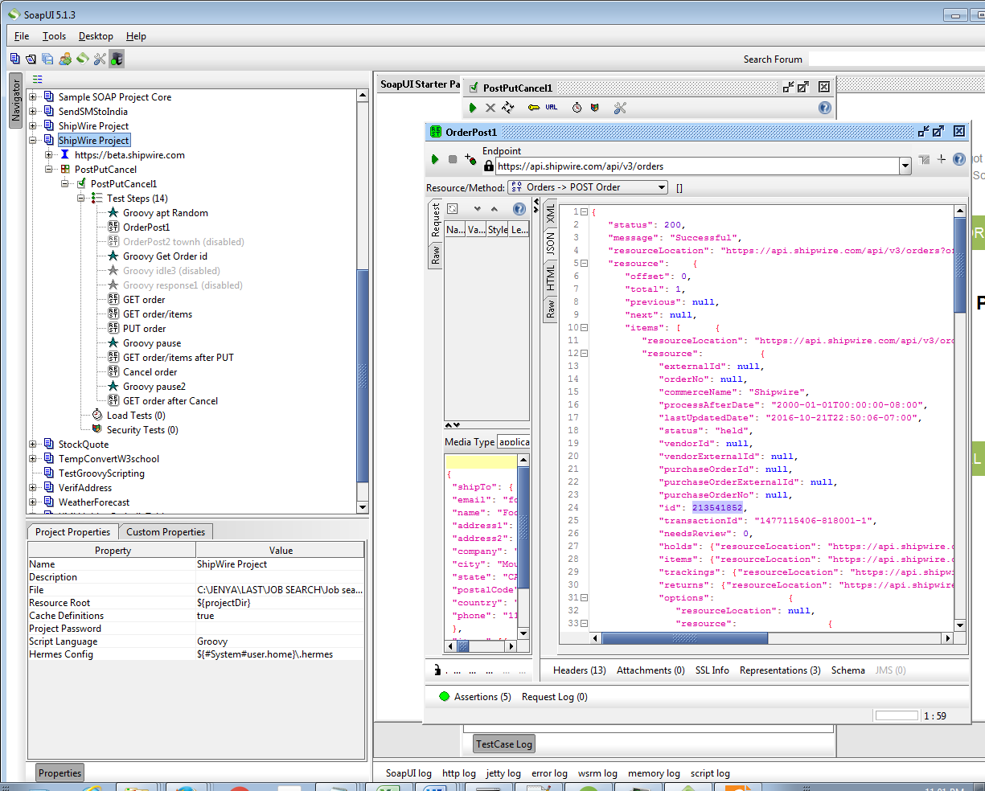

Double click at test case PostPutCancel1 and run it :

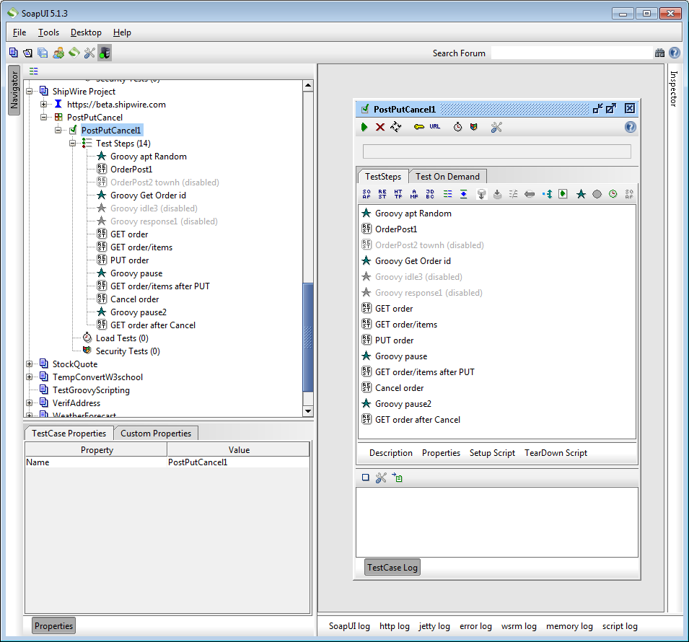

Order id after run clone- test case :

213543932

